AI WEATHERWISE

PROJECT PHASES

Project Title – WeatherWise AI – Deliver Intelligent Weather
Forecasts and Insights.

Team ID – SWTID-2026-6359

Team Leader -
Raj Kumar M - manivannan30091980@gmail.com
Team Members –

Pasupathi M - pasupathimaster@gmail.com
Prathish R - praveenprathish123@gmail.com
Rachin K - rachinrachin194@gmail.com

PHASE 7
DEMONSTRATION, RESULTS & TESTING

10. API Testing and Demonstration

10.1 Testing Environment
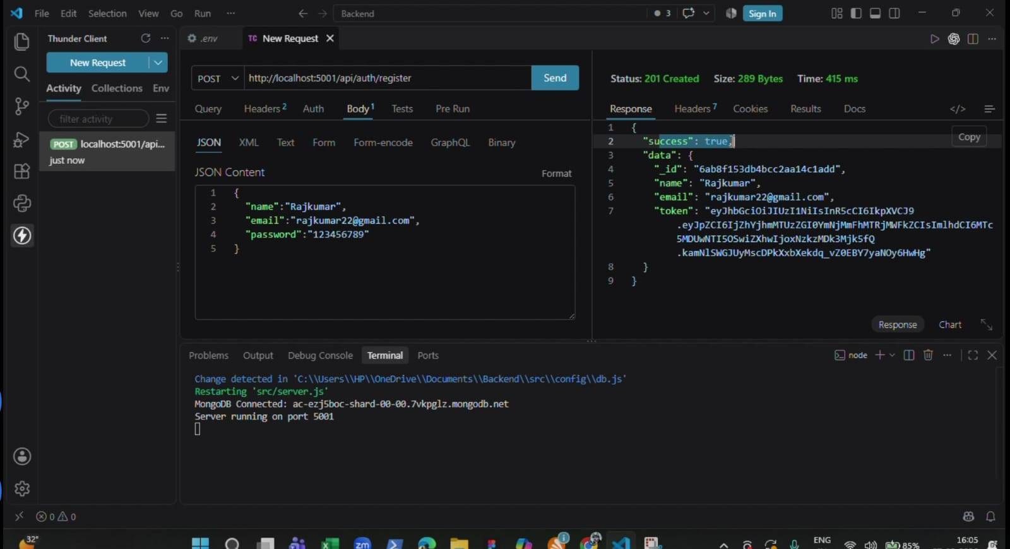
The supplied demo video shows the backend running locally in Visual Studio Code and API requests being tested using Thunder Client. The demonstration includes authentication, weather retrieval and AI-powered endpoints. Register API

10.2 Login API
The login request successfully returned an authentication response containing a JWT token. This demonstrates the authentication flow used for protected requests.
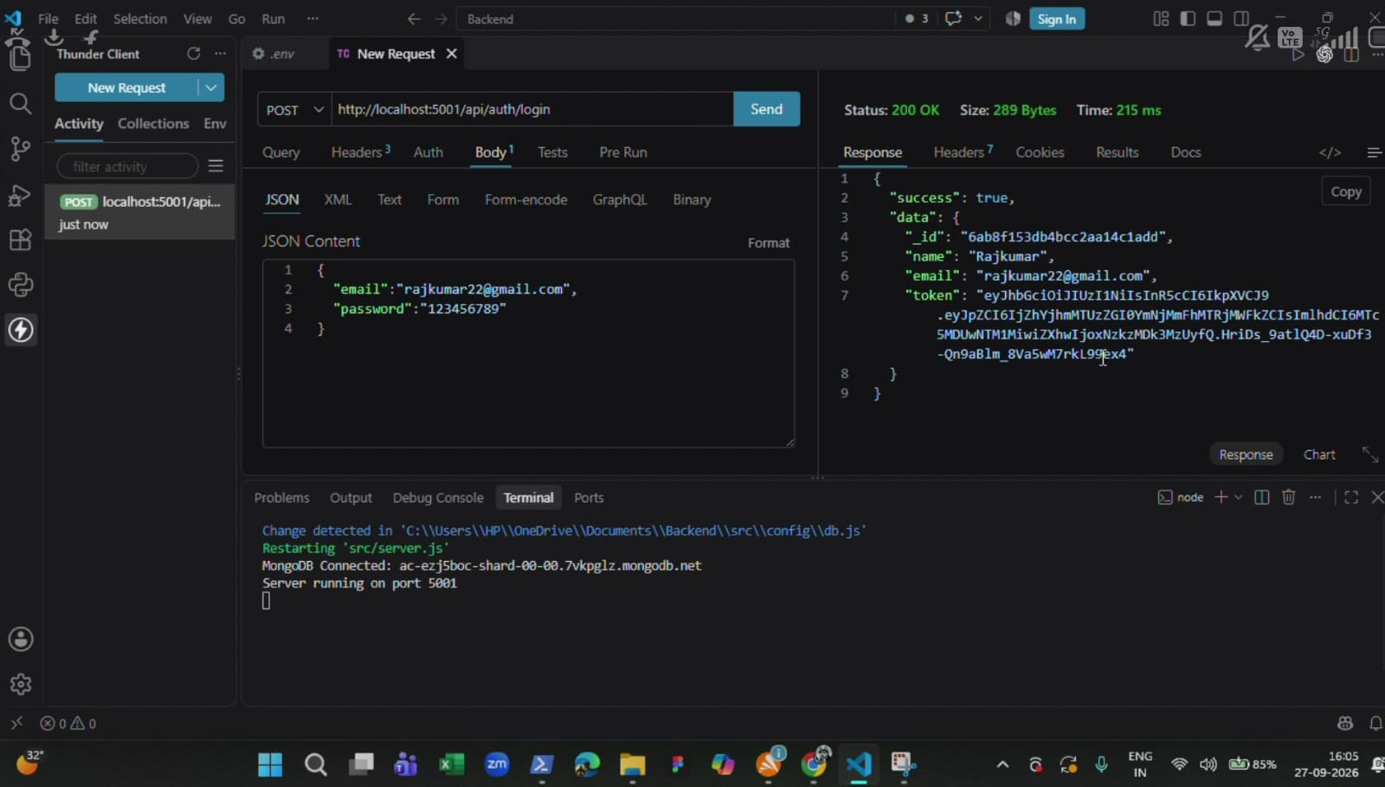

10.3 Testing Note
The demo verifies that the backend can receive requests and return structured responses through the API testing client.

11. Weather and AI Demonstration Results

11.1 Weather API Test
The demonstration shows a successful weather response for Chennai containing weather-related fields such as temperature, humidity, wind speed, condition and is Mock.
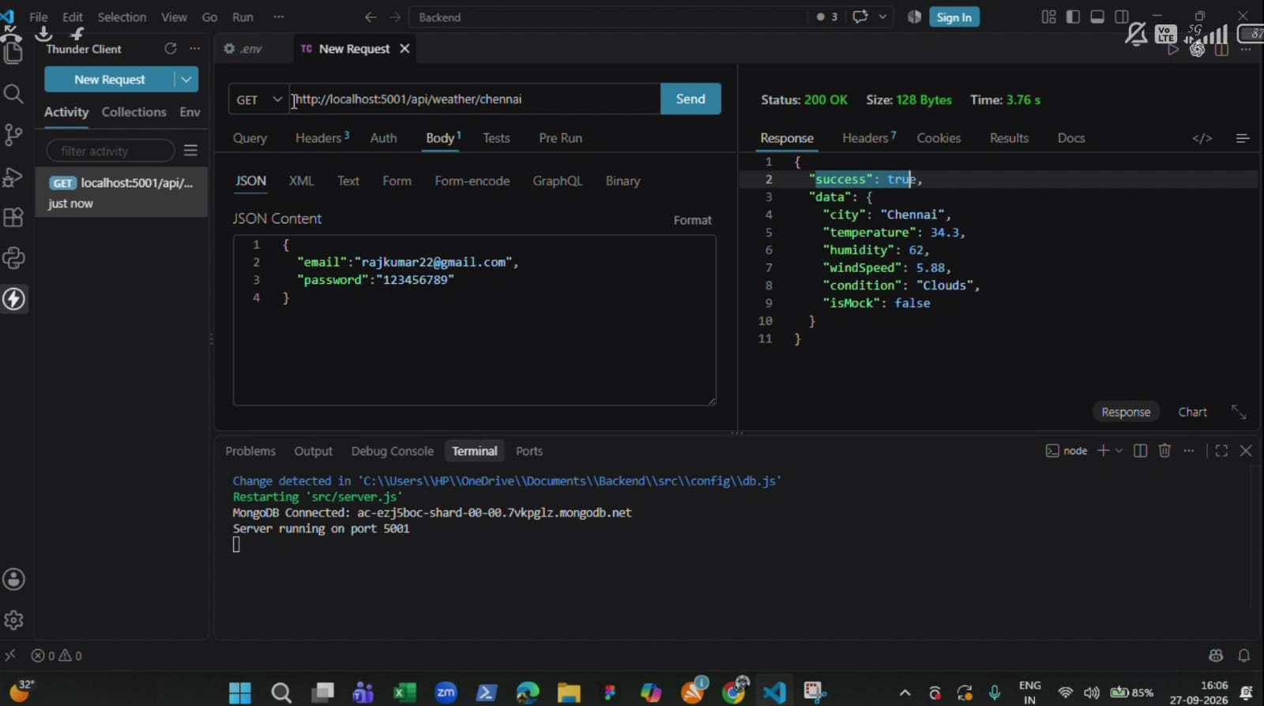

11.2 AI Summary
The AI summary endpoint returns natural-language information derived from the weather values.

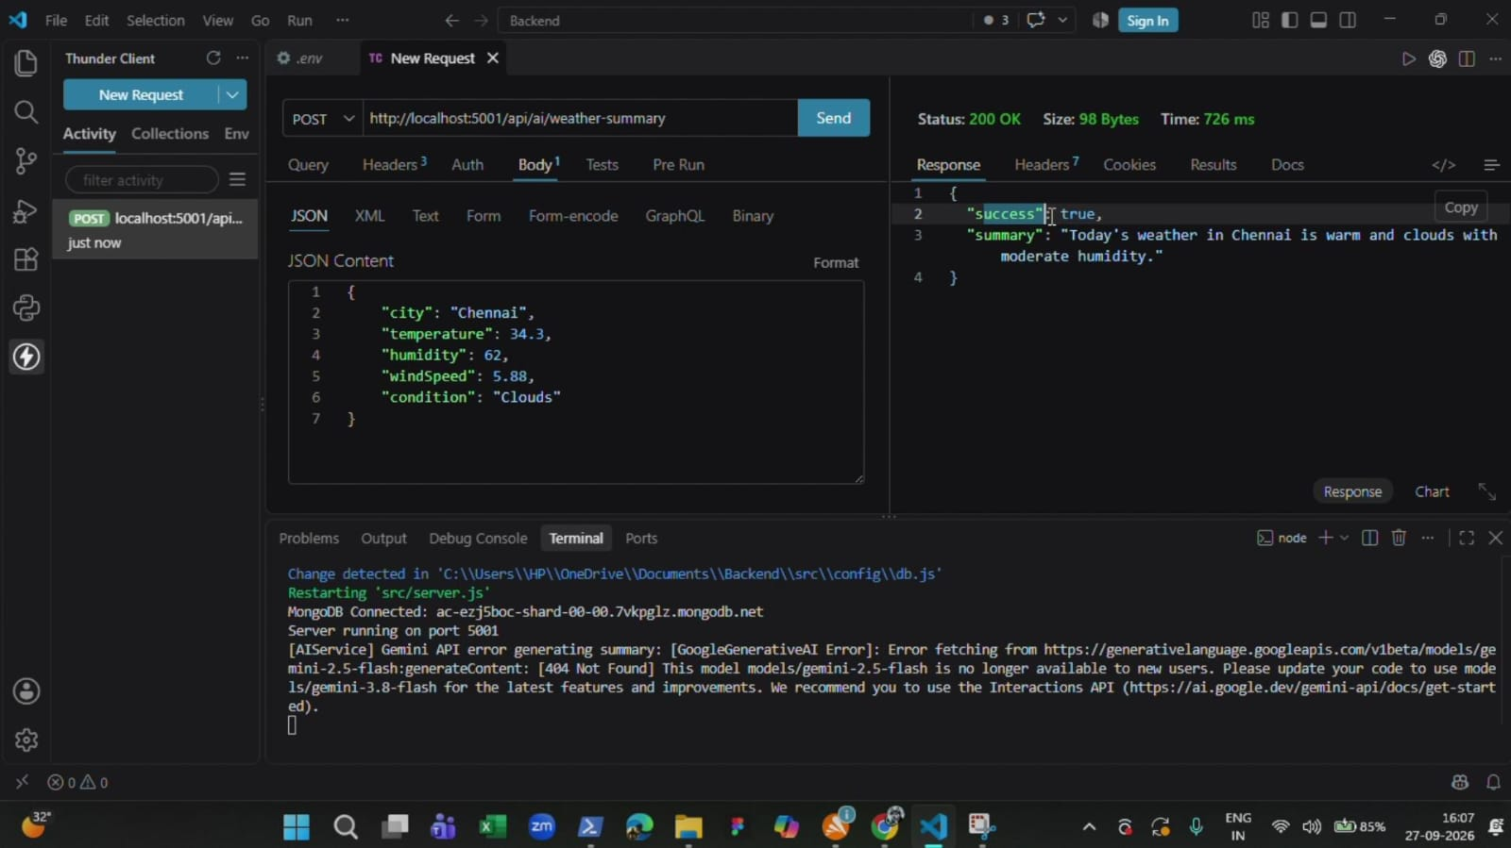

12. Recommendation, Testing and Results

12.1 Recommendation API
The recommendation endpoint returns practical guidance based on the weather information. The project demonstration shows the recommendation workflow through the API testing client.

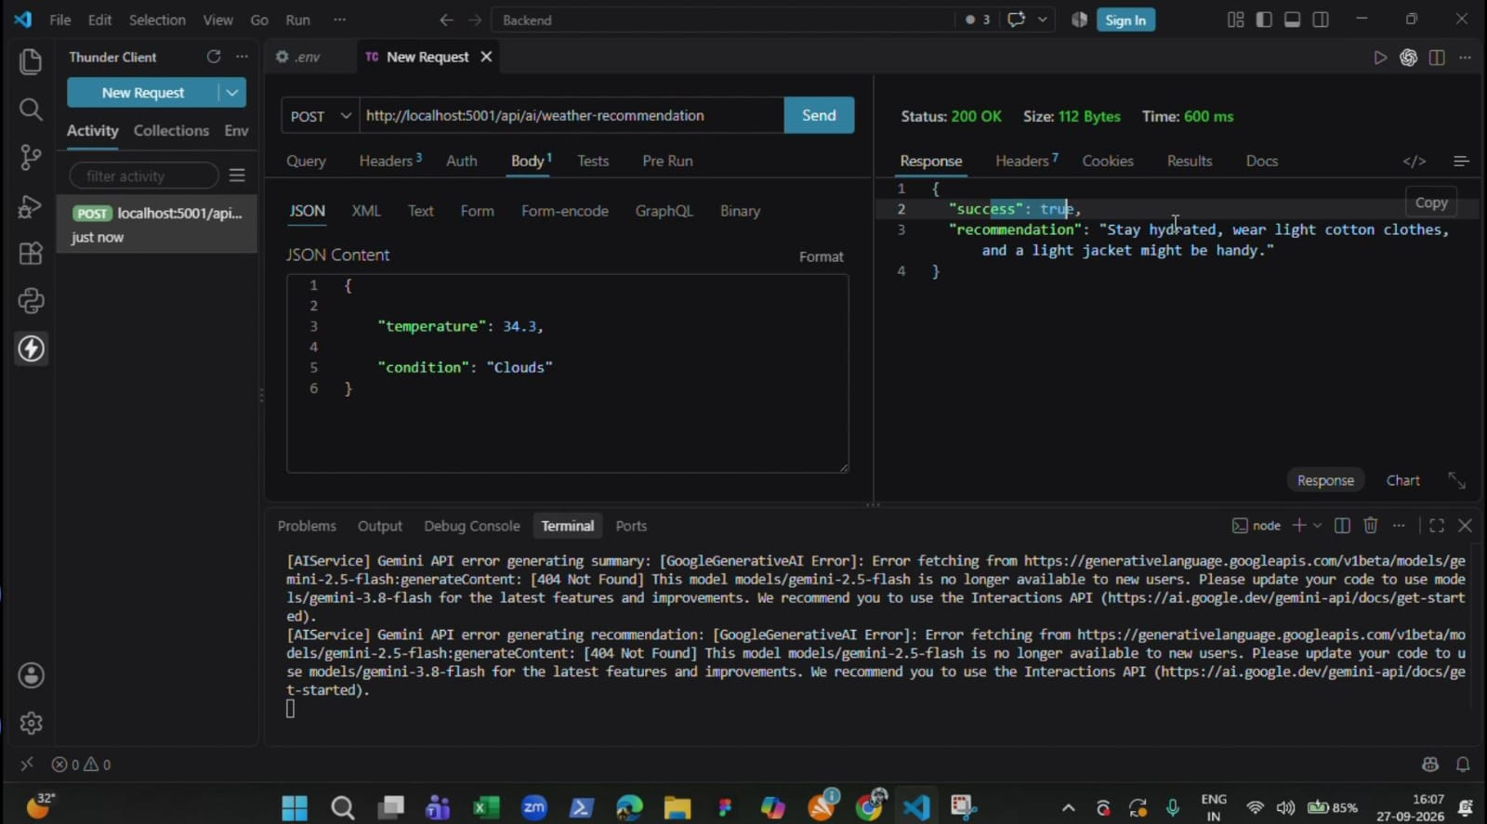

12.2 Test Observations
- Backend server was running locally during the demonstration.
- MongoDB connection status was visible in the terminal.
- Login returned a JWT token.
- Weather endpoint returned structured weather values.
- AI summary returned natural-language weather information.
- Recommendation endpoint returned actionable advice.

12.3 Limitations Observed
- The demonstration is mainly backend/API oriented; a complete end-user UI is not shown.
- An AI model/API availability issue appears during one part of the demonstration.
- The written reference uses port 5000 while the demo shows local execution on port 5001.

